ECE 406 Course Notes

Algorithm Design and Analysis

Paolo Torres

**University of Waterloo**

**Winter 2021**

Table of Contents

1 Introduction and Basic Arithmetic 1

1.1 Algorithms, Correctness, Termination, Efficiency 1

1.1.1 Algorithms 1

1.1.2 Correctness 1

1.1.3 Termination 1

1.1.4 Time Efficiency 2

1.1.5 Claim 1 2

1.1.6 More Efficient Algorithm 3

1.1.7 Note on Measuring Time Efficiency 3

1.2 Big-O Notation 3

1.2.1 Definition 1 (O) 3

1.2.2 Definition 2 () 3

1.2.3 Definition 3 () 3

1.2.4 Example 4

1.2.5 Big-O Explanation 4

1.2.6 Big-O Simplifications 5

1.3 Arithmetic 5

1.3.1 Addition 5

1.3.2 Multiplication 5

1.3.3 Division 6

2 Algorithms with Numbers 7

2.1 Modular Arithmetic 7

2.1.1 Example Application: Two’s Complement Arithmetic 7

2.1.2 Modular Addition, Subtraction 8

2.1.3 Modular Multiplication 8

2.1.4 Modular Exponentiation 9

2.1.5 Towards Modular Division: GCD Using Euclid 9

2.1.6 Towards Modular Division: Extended Euclid 10

2.1.7 Modular Division 11

2.2 Primality Testing 11

2.2.1 Fermat’s Little Theorem 12

2.3 Generating an n-Bit Prime 13

2.4 Cryptography 13

2.4.1 Claim 1 14

2.4.2 Example 14

2.4.3 Attacks 15

2.4.4 Proof for Claim 1 15

3 Universal Hashing, Divide and Conquer 16

3.1 Universal Hashing 16

3.1.1 Example 16

3.1.2 Two Possible Candidates for 16

3.1.3 Hash Table Objectives 17

3.1.4 Problem Setup 17

3.1.5 How a Hash Table Works 17

3.1.6 Universal Hashing 18

3.1.7 How to Construct Given 19

3.2 Divide and Conquer 21

3.2.1 Definition 21

3.2.2 Solving Recurrences 23

3.2.3 Sorting Problem 24

3.3 Divide and Conquer Applications 25

3.3.1 Selection Problem 25

3.3.2 Matrix Multiplication 27

# Introduction and Basic Arithmetic

## Algorithms, Correctness, Termination, Efficiency

### Algorithms

Given the specification for a function, an algorithm is the procedure to compute it.

Example:

, where

Commonly used sets:

Fibonacci Sequence:

Important aspects:

* Function has been specified as a recurrence, so a recursive algorithm seems natural
* Imperative (procedural) specification of an algorithm has consequences:
  + Intuiting correctness can be a challenge
  + Intuiting time and space efficiency may be easier
* No mundane error checking, can focus on core logic
* Input value is unbounded but finite

### Correctness

Correctness refers to an algorithm’s ability to guarantee expected termination. In the case of , it is a direct encoding of the recurrence.

### Termination

The end of an algorithm. It can be proven that terminates on every input by induction on .

### Time Efficiency

Can be calculated by counting the number of: comparisons – these happen on Lines and , and number of additions – this happens on Line .

Suppose represents the time efficiency of :

How bad is ? Is it exponential in ?

For all , .

### Claim 1

For all

If this claim is true, then , and because , is exponential in .

Proof for the claim: by induction on .

Does a better algorithm exist from the standpoint of time efficiency?

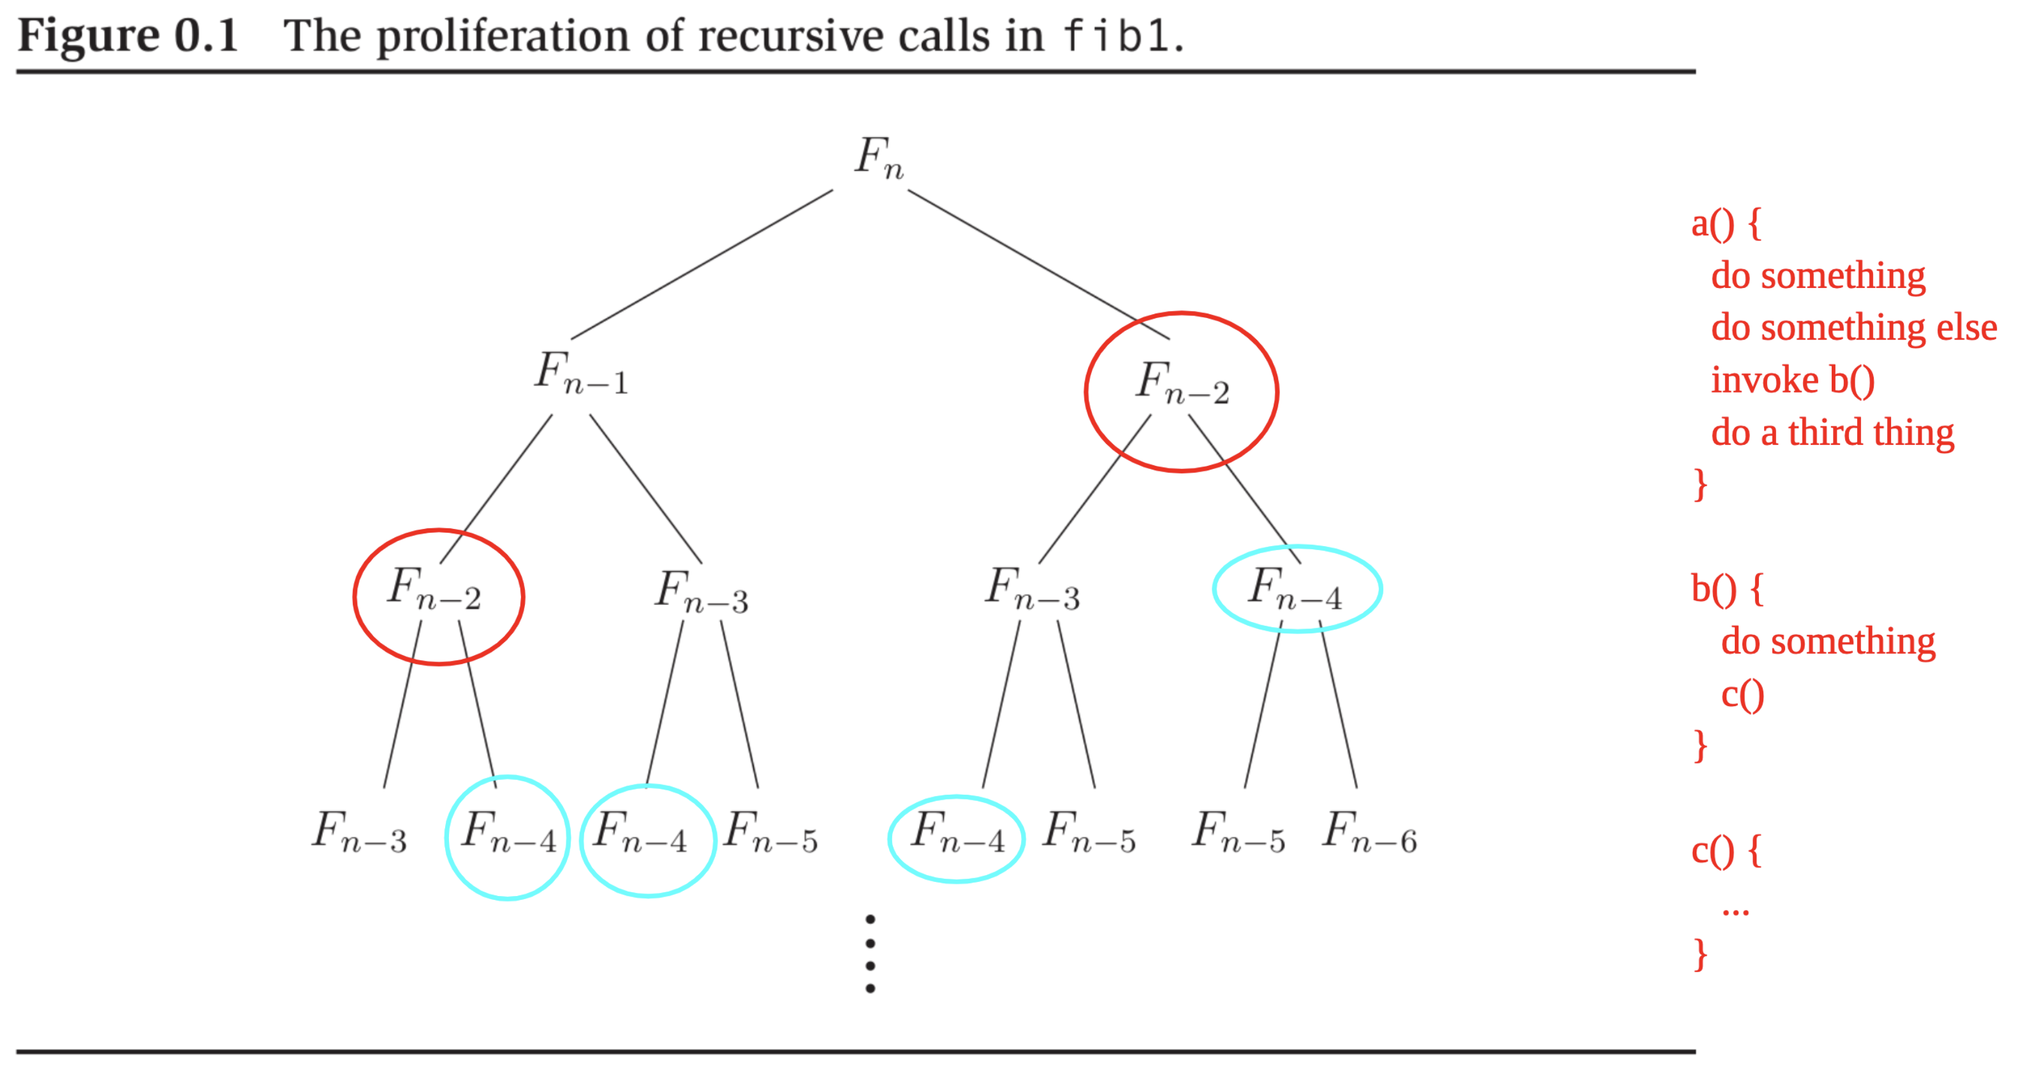

Recall how subroutine (recursive, in this case) invocation works:

* Every node in the tree corresponds to an invocation of the algorithm
* Sequence of invocations corresponds to a pre-order traversal
* Maximum depth of the call stack at any moment:

Main point in this case: Redundancy, , appears more than once.

### More Efficient Algorithm

Let be the of comparisons plus additions on input :

Linear in for , more efficient than .

### Note on Measuring Time Efficiency

Need to pick the right level of abstraction, meaning picking some kind of “hot spot” or “hot operation,” then count. For example, number of additions, comparisons, recursive calls, etc.

## Big-O Notation

### Definition 1 (O)

Let , and be functions. Define if there exists a constant such that .

* Typically consider non-decreasing functions only

### Definition 2 ()

Define if

### Definition 3 ()

Define if and

* analogous to
* analogous to
* analogous to

### Example

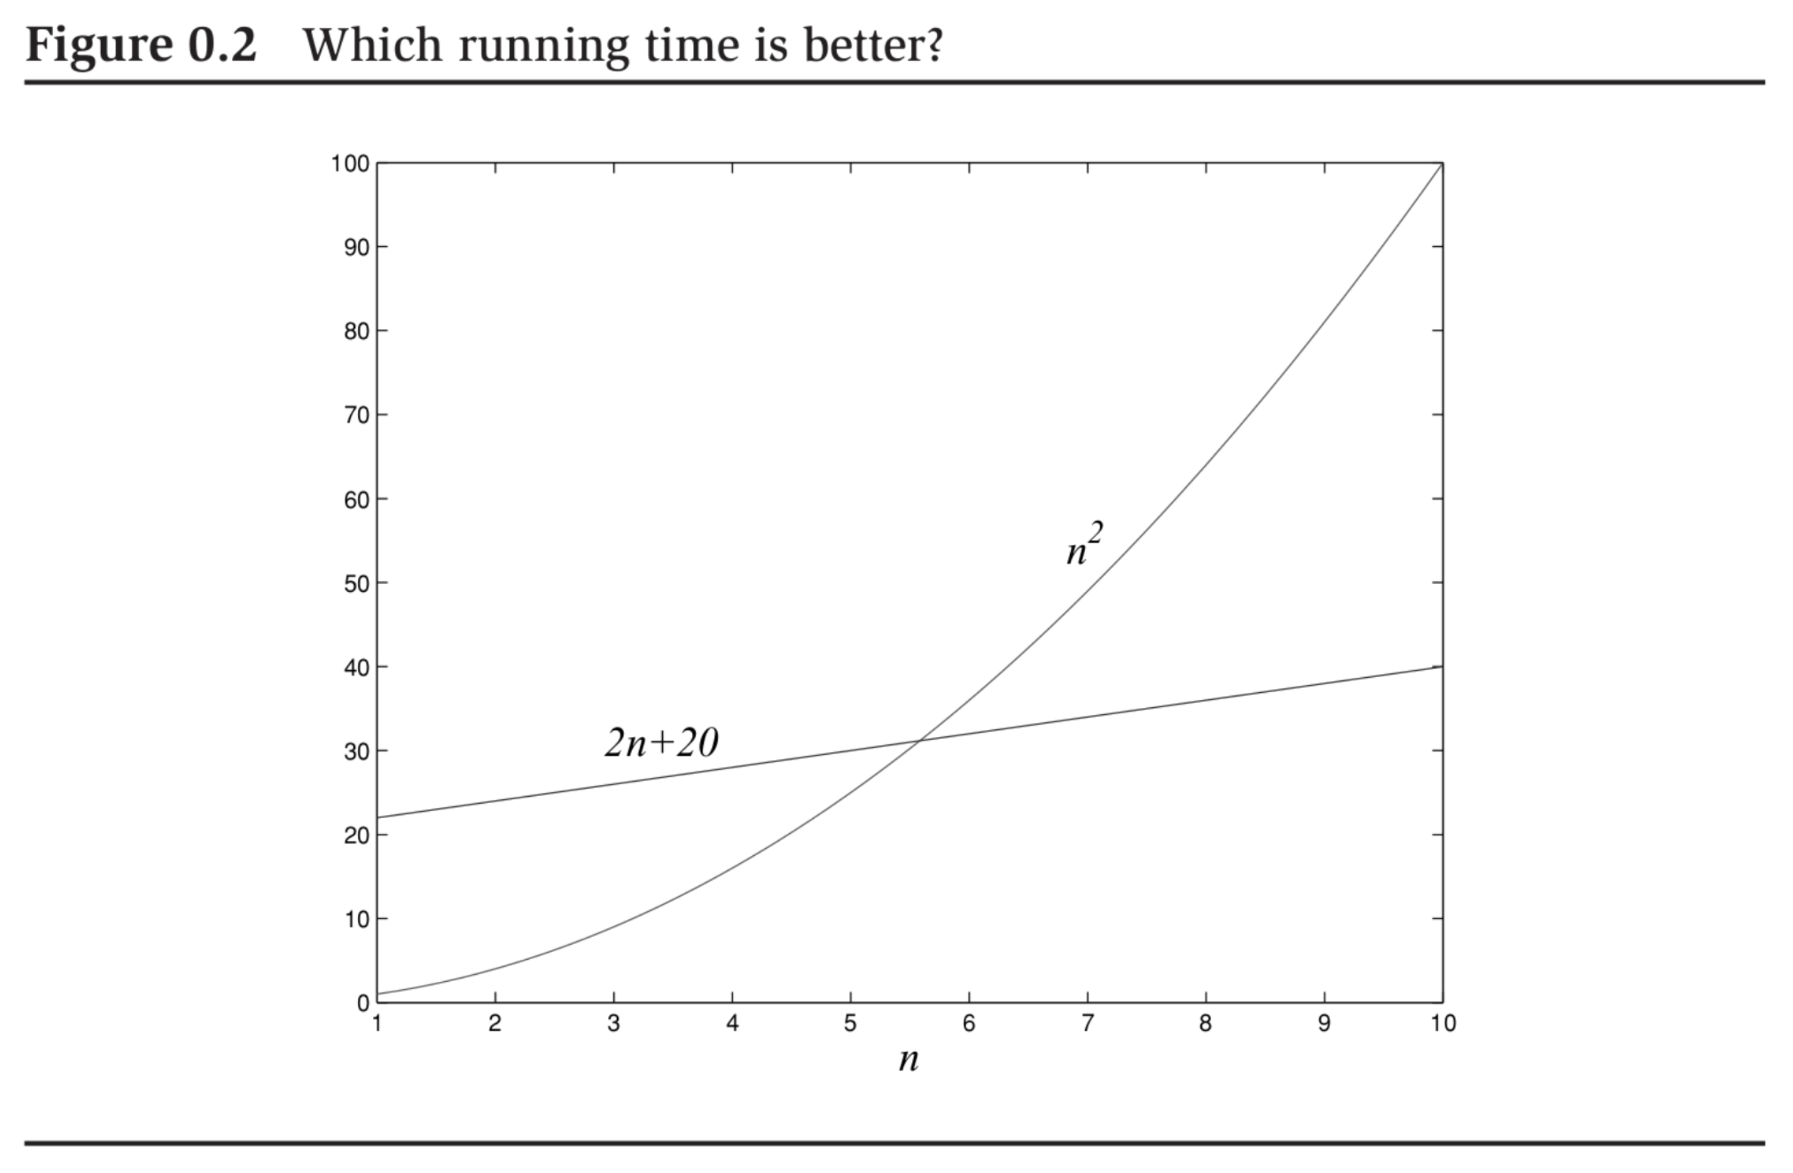

Precise answer to this question: depends on .

But in big-O notation:

* . Proof: Adopt as the constant for any

### Big-O Explanation

Suppose algorithm A runs in time, B in , and C in . Now suppose the speed of the computer doubles, which algorithm gives the best payoff?

For a given time period , what is the largest input each algorithm can handle? Set and , solve for :

|  |  |  |
| --- | --- | --- |
| **Algorithm** | **Old Computer** | **New Computer** |
| A |  |  |
| B |  |  |
| C |  |  |

So, payoff with algorithm A is approximately , B is , and C is .

### Big-O Simplifications

* Multiplicative and additive constants can be omitted
* dominates for
* Any exponential dominates any polynomial, any polynomial dominates any logarithm
* Big-O simplifications should be used prudently, not applicable in all settings

## Arithmetic

### Addition

Hypothesize access to a function :

|  |  |  |  |  |
| --- | --- | --- | --- | --- |
| **Carry** | **One Digit** | **Other Digit** | **Result Carry** | **Result Sum** |
| 0 | 0 | 0 | 0 | 0 |
| 1 | 0 | 0 | 0 | 1 |
| 0 | 0 | 1 | 0 | 1 |
| … | | | | |
| 1 | 8 | 9 | 1 | 8 |
| 0 | 9 | 9 | 1 | 8 |
| 1 | 9 | 9 | 1 | 9 |

To add and :

digits needed to encode

bits needed to encode

So, time efficiency of an algorithm to add as measured by number of lookups to T:

* in the best case
* in the worst case
* So, either way, , or linear time, where is the size of the input

### Multiplication

For , encoded in binary:

Straightforward encoding as recursive algorithm .

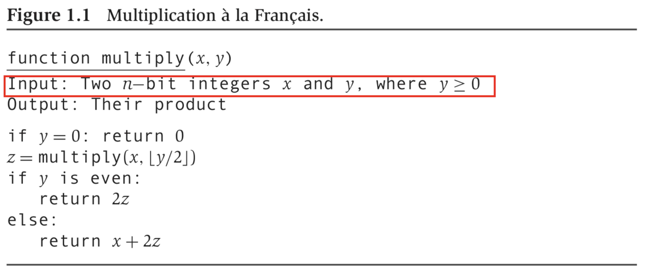

Worst case running time:

* + One comparison to , one division by (right bit shift), one assignment to , one check for evenness (check LSB), one multiplication by (left bit shift), one addition of -bit numbers
* So, in the worst case

### Division

**Definition 1:** Given , the pair where , of divided by are those that satisfy:

**Claim 1:** For every , , as defined above exists, and is unique.

To specify a recurrence for , denote as , the result of divided by . Now:

**Claim 2:** The above recurrence is correct.

*Proof:* Cases are exhaustive. Proof by case-analysis and induction on bits to encode .

By induction assumption: .

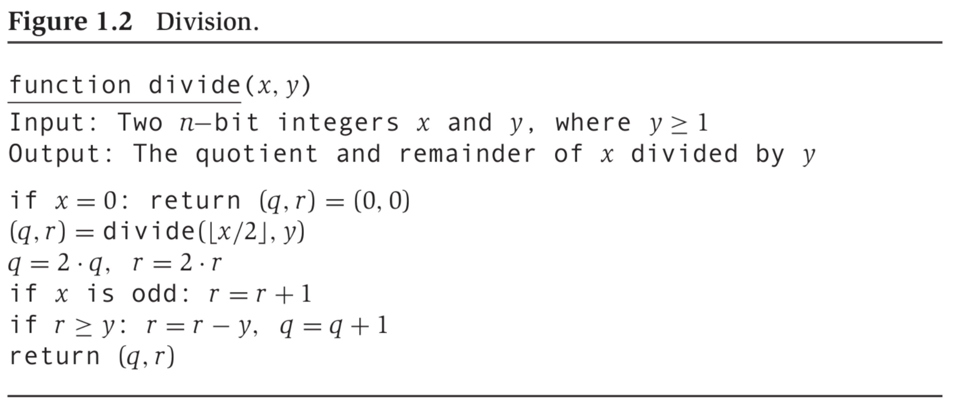

Running time: .

# Algorithms with Numbers

## Modular Arithmetic

* **Definition 1:**
* **Definition 2:** 
  + Example:

### Example Application: Two’s Complement Arithmetic

Suppose we want to represent, using bits, positive and negative integers, and . Could reserve bit for sign. This would allow us to represent integers in the interval , with a “positive zero” and a “negative zero.”

In two’s complement arithmetic, we have exactly one bit-string for , and represent integers in the interval . How? Represent any as the non-negative integer modulo . So:

* Ex:
* Ex:

All arithmetic performed modulo :

* Ex:

**Claim 1:**

**Claim 2:**

(mod N) (mod N) (mod N)

Example:

### Modular Addition, Subtraction

* Any intermediate result is between and
* So, time efficiency is , where

### Modular Multiplication

Let and be our algorithms for non-modular multiplication and division:

* Any intermediate result (specifically, result of ) is between and
* So, time efficiency is , where

### Modular Exponentiation

* Recall: We used “repeated doubling” for non-modular multiplication and “repeated halving” for non-modular division
* Similarly, here, use “repeated squaring”:

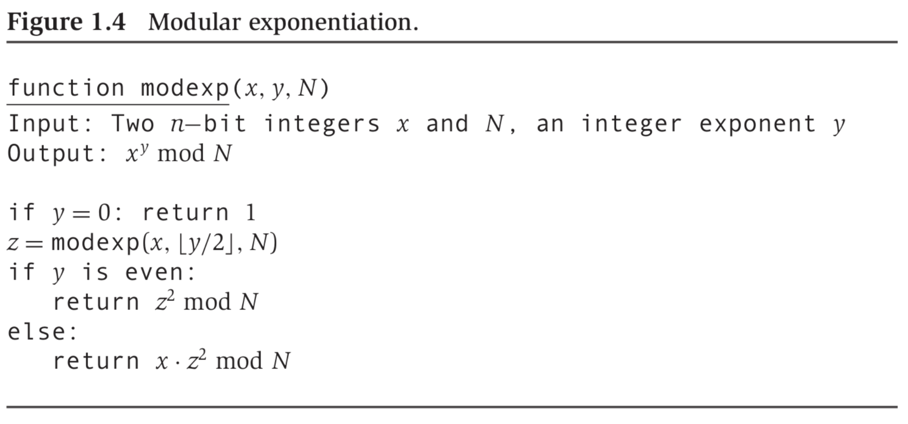

### Towards Modular Division: GCD Using Euclid

* In a non-modular world, . Only case for which doesn’t exist:
* In a modular world, may not exist even if

Crucial building block: GCD. Example: What is ?

But factoring into prime factors conjectured to be computationally hard in the worse case

**Claim 3:**

*Proof:* Suffices to prove: . Now prove and .

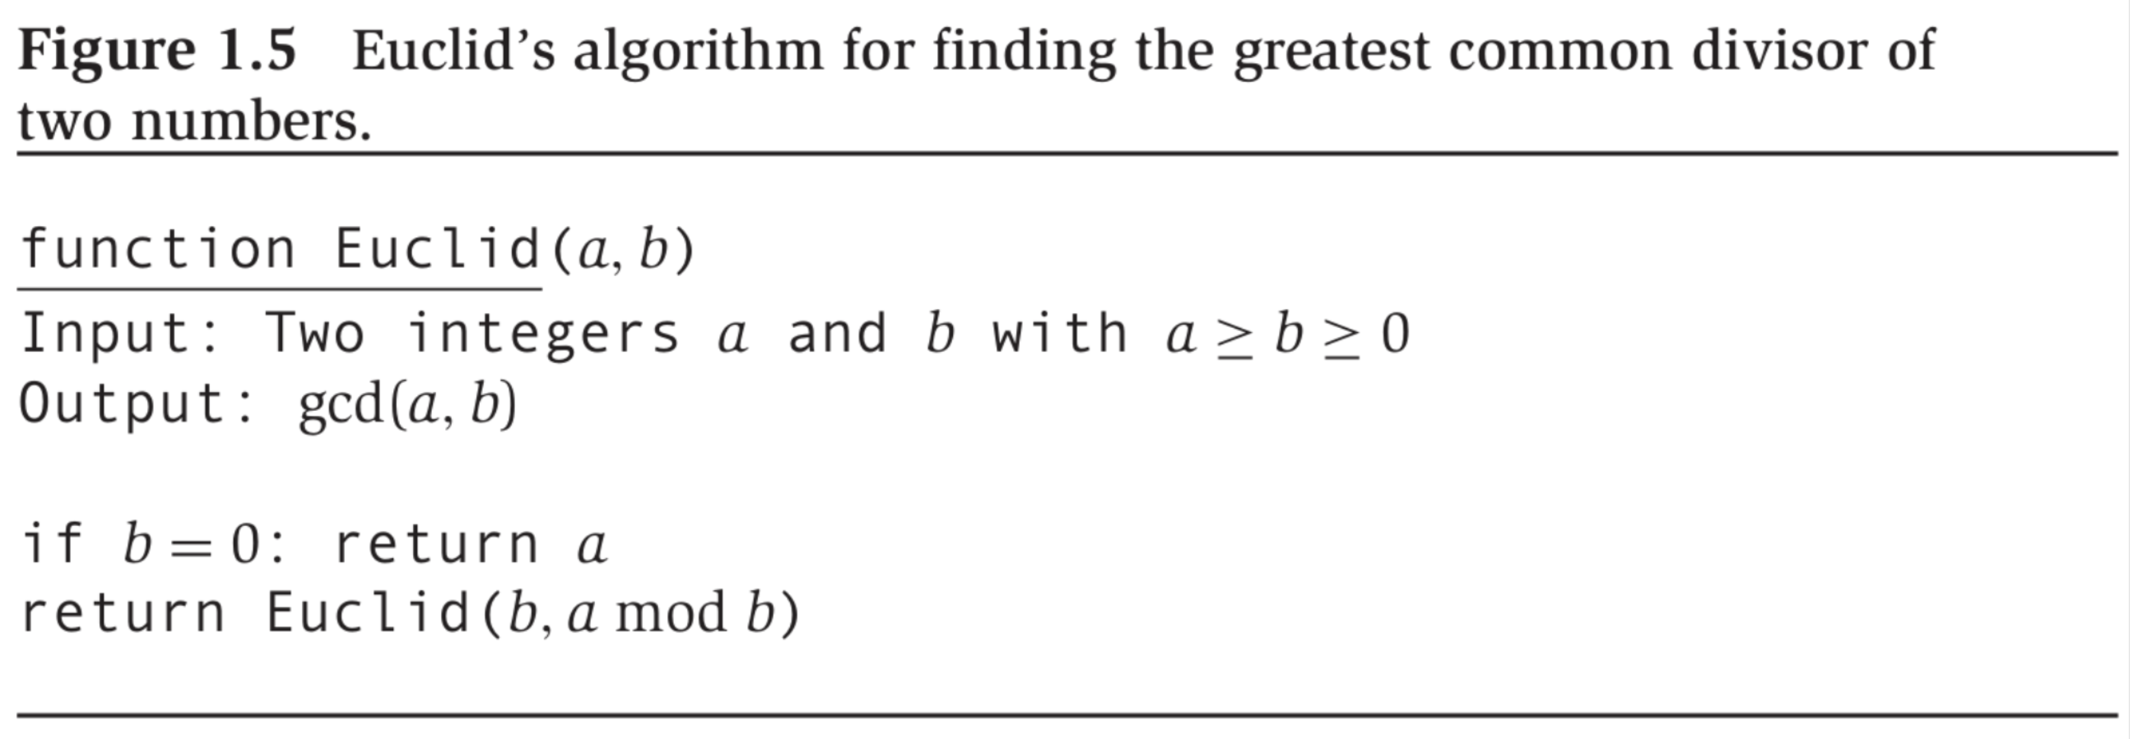

How fast does converge?

**Claim 4:**

So: Guaranteed to lose at least bit for every recursive call time efficiency is

### Towards Modular Division: Extended Euclid

**Claim 5:**

**Claim 6:**

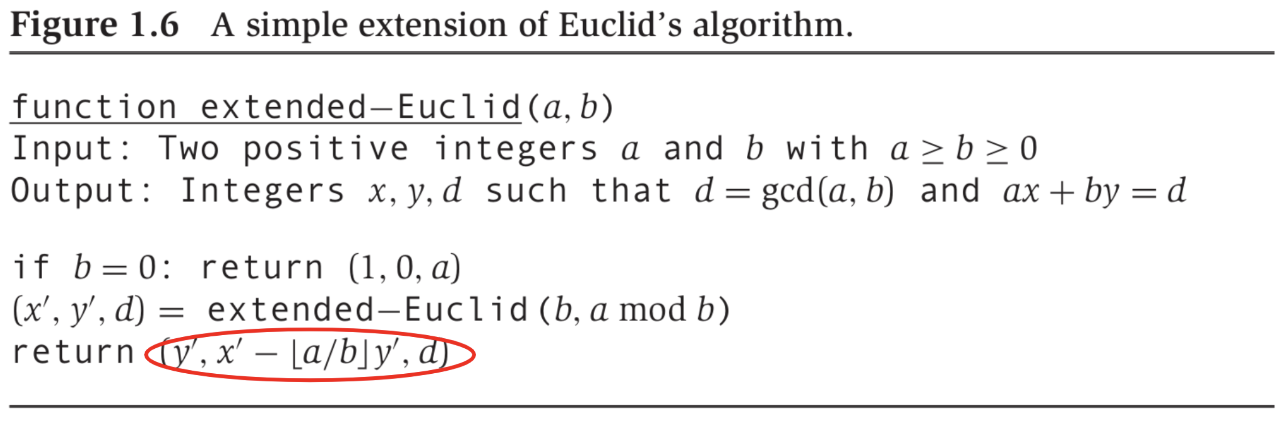

Example run on input :

|  |  |
| --- | --- |
| **Arguments** | **Return Value** |
|  |  |
|  |  |
|  |  |
|  |  |
|  |  |
|  |  |
|  |  |
|  |  |

A good example to segue to our final step in modular division.

We figured out: , which implies:

* . So: is multiplicative inverse of
* So, for example:

### Modular Division

**Definition 3:**

**Claim 7:**

**Claim 8:**

**Definition 4:**

**Claim 9:**

So, to compute :

1. Determine whether
2. If yes to (i) determine , and
3. If yes to (i) compute

(i) and (ii) are done simultaneously by

Running Time:

## Primality Testing

Given , is prime?

For a decision problem, i.e., co-domain of function to be computed as , a randomized algorithm:

* Has access to an unbiased coin
* Is deemed to be correct if:

Suppose:

* We run such an algorithm times, pairwise independently
* We return if and only if every run returns
* Then,

### Fermat’s Little Theorem

**Claim 1:**

To prove Fermat’s little theorem, leverage the following:

**Claim 2:**

*Proof for Claim 2:* We know that are relatively prime, so exists.

*Proof for Claim 1:* From Claim 2:

Also, exists.

So,

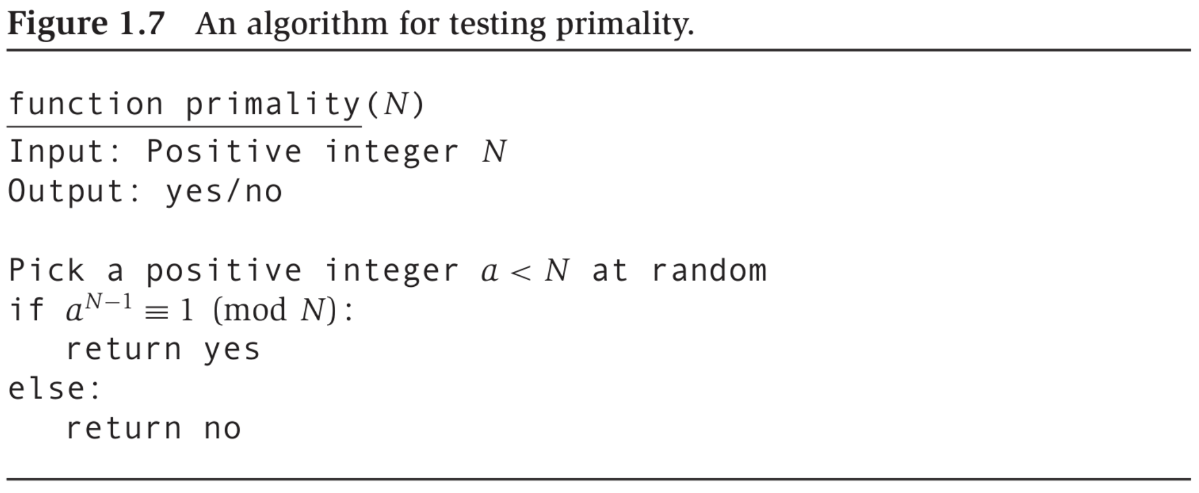

Issues with the algorithm:

1. Fermat’s little theorem is not an “if and only if”: Carmichael numbers.
2. Suppose is not prime/Carmichael. For chosen, say, uniformly from , what is ?

* We know such an exists, but how likely is it that we will pick it?

We do not deal with (1) – cop out: Carmichael numbers are rare.

**Claim 3:** If for relatively prime, then it must hold for at least half the choices .

*Proof:* If there exists no with , then we are done.

If such a exists, then .

Also, if exist with , , then:

So, at least as many as there are .

So:

For runs of on uniform, independent choices of :

## Generating an n-Bit Prime

**Claim 4:** .

So, algorithm for generating a prime:

1. Randomly generate -bit number, .
2. Check whether is prime.
3. If not, go to Step (1).

Guaranteed return in Step (2) if is indeed prime.

Each trial in the above algorithm is a Bernoulli trial:

* Only one of two outcomes: success or failure

In a Bernoulli trial if , then

* Example:
* Example:

So, we expect the above algorithm to halt in iterations.

## Cryptography

**RSA:** Exploits presumed computational hardness of factoring vs. computational ease of GCD, primality testing and modular exponentiation.

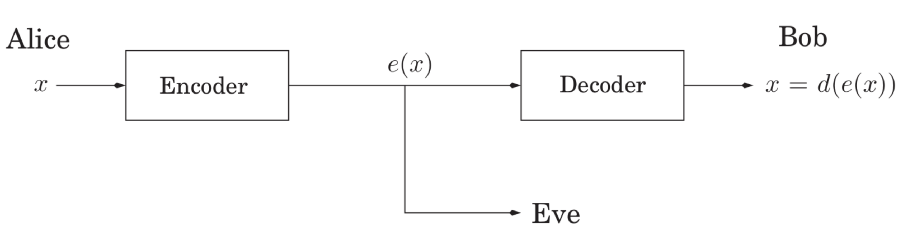

Symmetric Key Cryptography:

* + Example:
* They keep these secrets from everyone else
* Bootstrapping Problem: How do Alice and Bob share , ?

Public Key Cryptography:

* Bob publishes to the whole world
* Bob keeps to himself
* RSA is an example of a public key cryptography scheme

### Claim 1

Let be primes and . For any relatively prime to :

1. The function where is a bijection
2. Let . Then,

Bob publishes the pair . Alice encodes message as from the claim.

Bob keeps the in the claim secret to themselves.

### Example

. Then, . The only messages that can be sent: .

We could pick :

Then, : .

To send the message , Alice would send .

Bob would decode the message as .

### Attacks

Attacker knows: (i) , (ii) .

* Attack 1: Attacker determines given (i) and (ii).
* Attack 2: Even more devastating – attacker factors .
  + They can then compute .

### Proof for Claim 1

Property #2 implies Property #1.

To prove Property #2:

Because for some .

We seek to show: is divisible by , and is therefore .

Now, by Fermat’s little theorem: .

And again, by Fermat’s little theorem: .

So: is divisible by the product of the two primes .

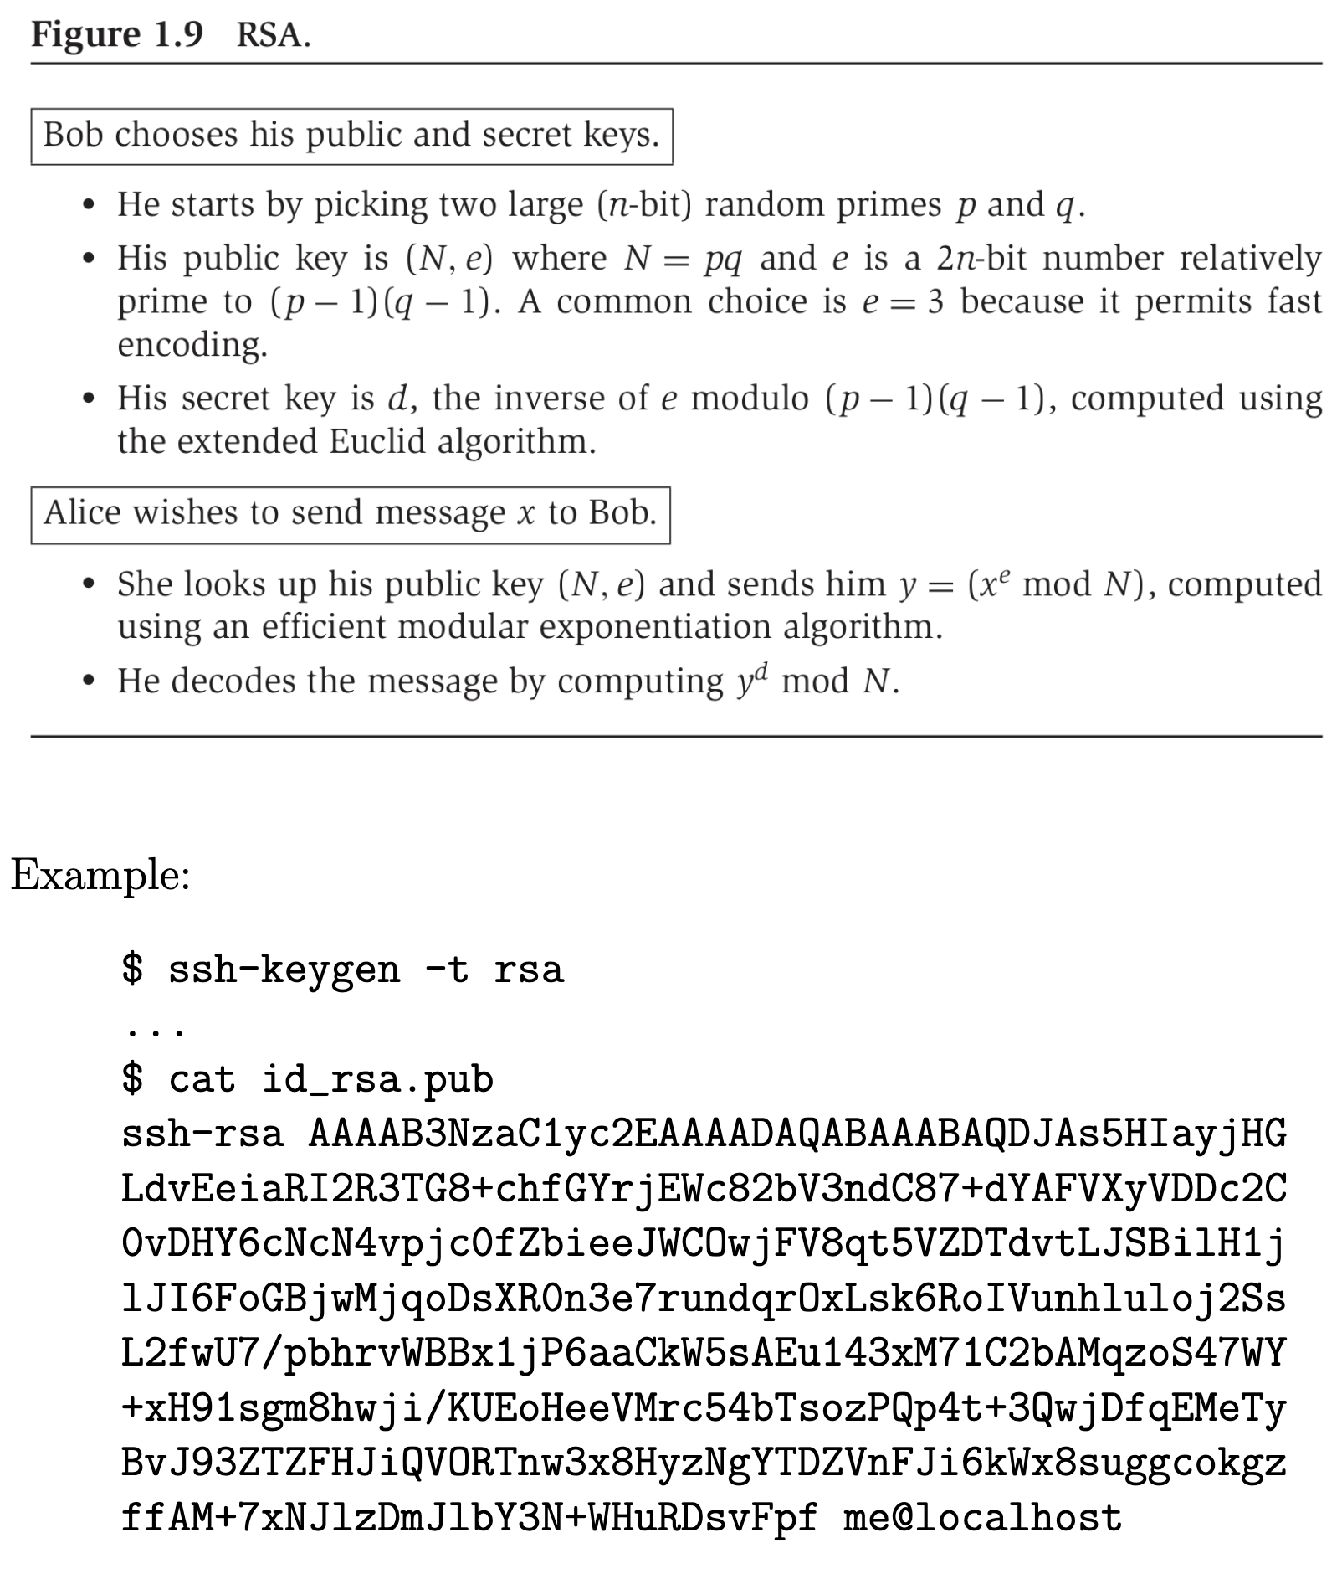

# Universal Hashing, Divide and Conquer

## Universal Hashing

### Example

University of Waterloo has data about students that looks something like:

|  |  |  |  |  |  |  |
| --- | --- | --- | --- | --- | --- | --- |
| **Student ID** | Last Name | First Name | Degree Objective | Date of Matriculation | Term 1 + Marks | … |

The Student ID is used to uniquely identify each student record. We call it a *key*. The remainder of the data for each student is called *satellite data*. The school seeks to store this data and retrieve it efficiently. Assume that is the data structure that stores all the data. For any given student record, , there is an efficient function , which returns the key, i.e., Student ID, associated with .

* : Creates a new, empty instance of and returns it. May take arguments, e.g., the space allocated to .
* : Insert the record into . If a record with already exists in , adopt some convention, e.g., replace it with this new one.
* : Remove the record associated with key in . If such a record does not exist, adopt some convention, e.g., leave unchanged.
* : Return the record associated with key from . If such a record does not exist, return a special string, e.g., .

What data structure, and associated algorithms, will you choose for ?

Answer: It depends on: how frequently is invoked compared to and/or , how much space is allowed to take, how efficiently needs to run.

### Two Possible Candidates for

Array, indexed by Student ID:

* Good: runs in time .
* Bad: Space inefficient. .

Linked List:

* Good: Highly space efficient.
* Bad: runs slowly.

### Hash Table Objectives

* Time Efficiency: to run in time .
* Space Efficiency: If we seek to store records, space we should have to allocate .

### Problem Setup

* We have a universe of keys, .
* We seek to store records each with a unique key. Typically, .
* Designer of hash table knows: , and , to some approximation.
* Designer of hash table does not know how the keys are chosen from .

### How a Hash Table Works

* Designer picks some space allocation, . Typically, . Each is called a bucket.
* Designer picks a *hash function*, : .
* Designer picks a strategy for *resolving collisions*.
  + Two distinct keys, are said to collide under if .
    - Collision guaranteed if .
    - Can be much worse: if , there exists a set of keys with that all hash to the same bucket, immaterial of choice of .
  + We consider collision resolution by *chaining* only.
  + If two records with keys need to exist in the hash table, and , then we maintain a linked list of the records in the bucket .

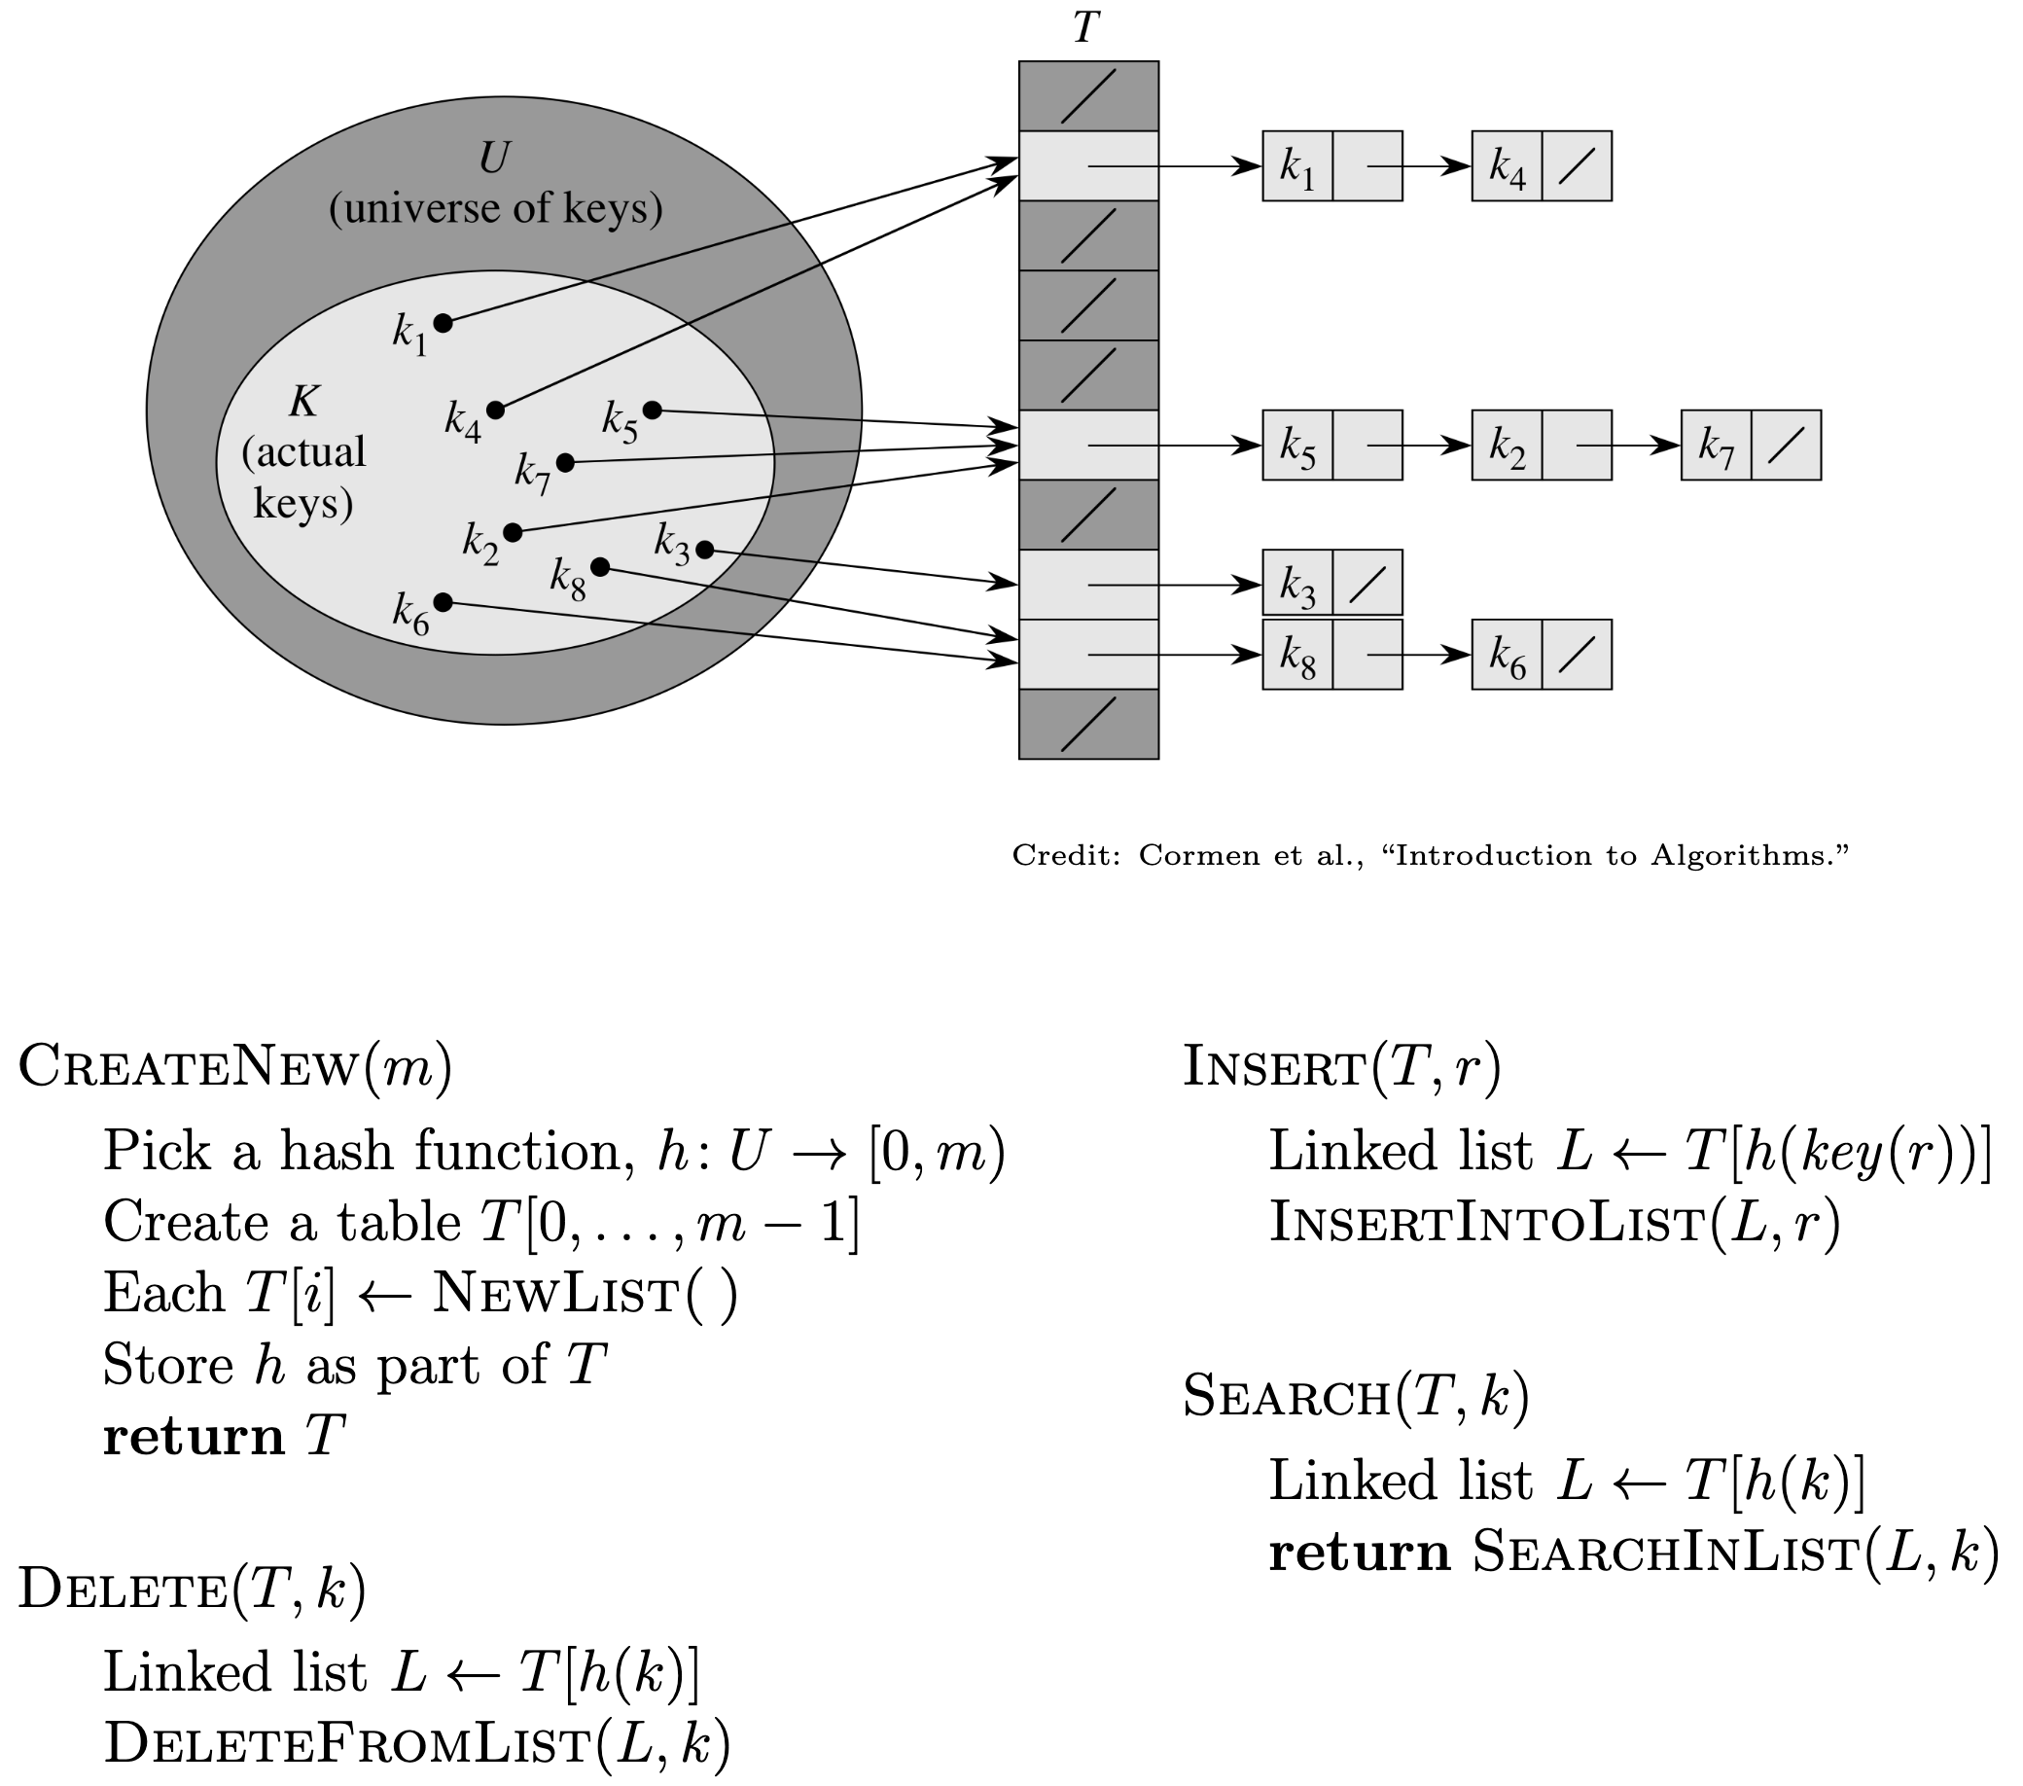

Choice of is critical to performance. What is an “ideal” ?

* Can be computed in time constant in .
* Minimizes collisions. More precisely, acts like a “random function.”
  + Suppose for all distinct .
  + Then in expectation, .
  + Then, if , expected time for is .
  + Note: Worst case time for remains .

### Universal Hashing

Given and , construct a set of hash functions with the following property:

Given any two distinct , the number of hash functions in for which and hash to the same bucket is .

Then, in , pick an from uniformly at random.

**Claim 1:** *Given a universal set of hash functions, , if we pick uniformly at random, then for all distinct .*

*Proof.*

Challenge: How to construct such an given .

### How to Construct Given

We use Student ID as keys: .

Now construct as follows:

* Generate some prime such that .
* For , let .
* Adopt .

Observation right off the bat: .

For the following claims, adopt:

* .
* chosen uniformly (at random) from their respective sets.
* .

**Claim 2:** .

*Proof.* , and neither nor . And so, .

**Claim 3:** *Let:*

*Then:*

*Proof.* *

Therefore, , a contradiction.

*\*Example:* and

These are both linear equations with unknowns . Now, are between and , and since is prime, is relatively prime to , and so its multiplicative inverse exists.

Thus, for distinct :

* Each distinct maps to distinct
* In each such .

Now:

* .
* .
* So to mapping is one-to-one.
* So, picking uniformly is equivalent to picking uniformly.

Finally, the part:

* Suppose each of is chosen uniformly at random.
* Then, for chosen uniformly.

To intuit the term, pictorially:

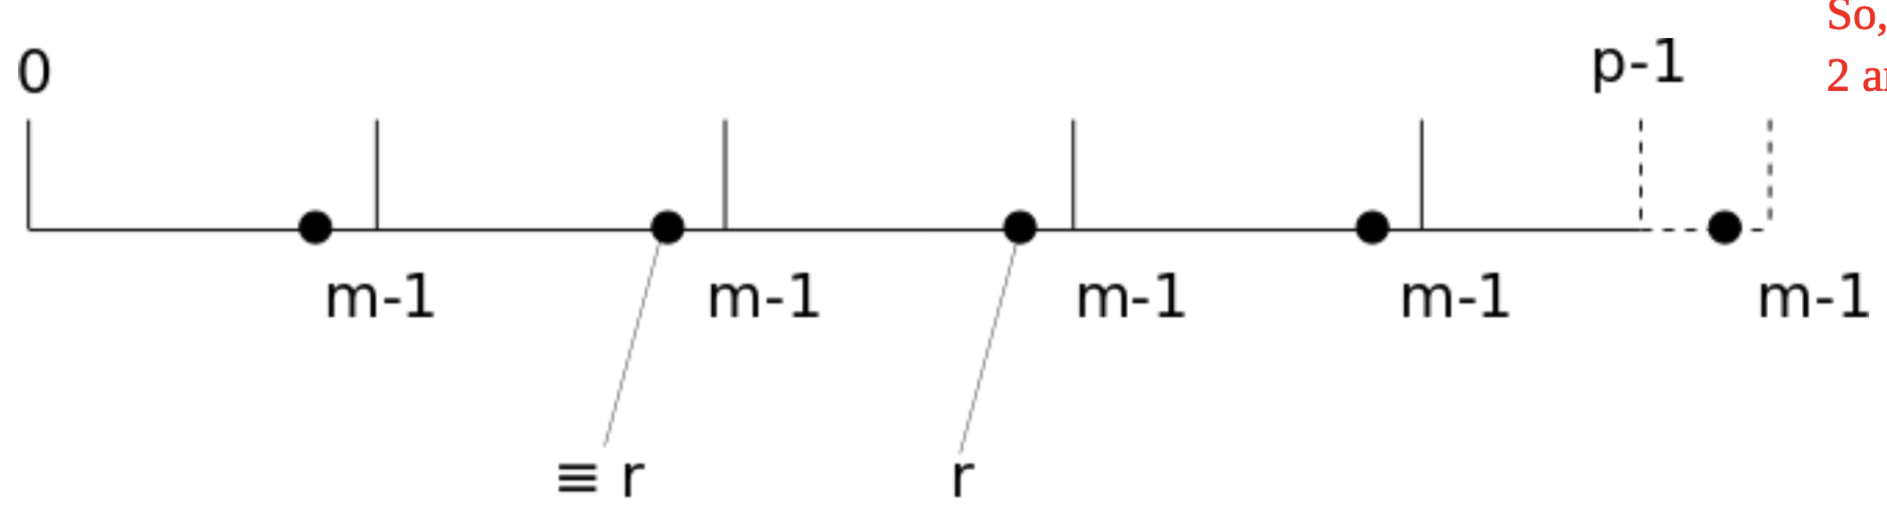

*In the figure, . The value , and every member of , but is shown as a bold dot.

And we know that . So:

*\*Example:* .

Then, .

So, in the set , the two numbers, and , are congruent modulo : .

## Divide and Conquer

### Definition

**Divide and Conquer:** An algorithm design strategy to which some problems lend themselves.

The *divide and conquer* strategy solves a problem by:

1. Breaking it into *subproblems* that are themselves smaller instances of the same type of problem
2. Recursively solving these subproblems
3. Appropriately combining their answers

Example: Compute the product given .

Assume our encoding is binary. First split the bits of each into the leading half the bits and trailing half the bits. E.g., .*

Then:

\**Example:* In base 10, e.g.,

So, to compute , where each is bits:

* Three multiplications of numbers bits long
* Two left bit shifts, one of bits and the other of bits
* Six additions/subtractions each of bits

Recurrence for running time, :

To solve the recurrence, draw a recurrence tree, which is equivalent to inductive “string rewriting” as follows.

First, for the term, we adopt a canonical function, , and for , we adopt .

: For what is ? Answer:

: , , then exponentiate by :

:

Subtract:

Implies:

### Solving Recurrences

Suppose we have the following recurrence for a function , with constants :

**Claim 1 (Master Theorem):** *Given as in the recurrence above,*

*Proof.* Draw a tree and count.

Example 1: Binary search on array of items. Running time, , as measured by # comparisons of items in the (sorted) input array and the item we’re searching for:

We have . So, , and .

Example 2: Recurrence for our algorithm for multiplication.

We have . So, , and .

### Sorting Problem

Given as input an array whose items are drawn from a totally ordered set, return the sorted permutation of .

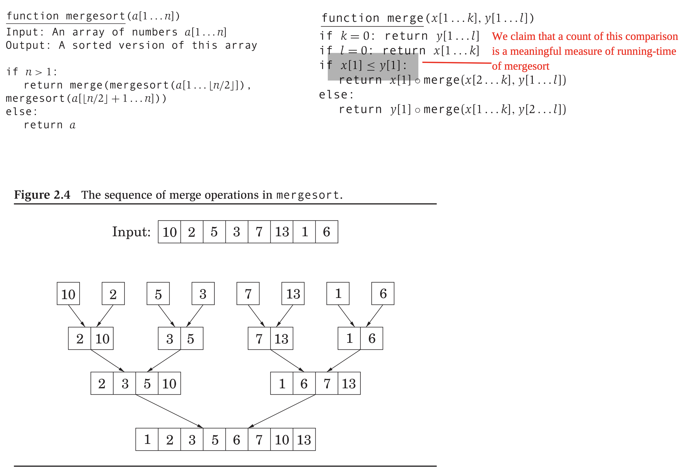

**Claim 2:**  *is correct.*

*Proof.* Induction on .

**Claim 3:**  *is correct.*

*Proof.* Induction on . Appeal to Claim 2.

.

**Claim 4:**  *is optimal in the # comparisons: any comparison-based sorting algorithm performs comparisons*.

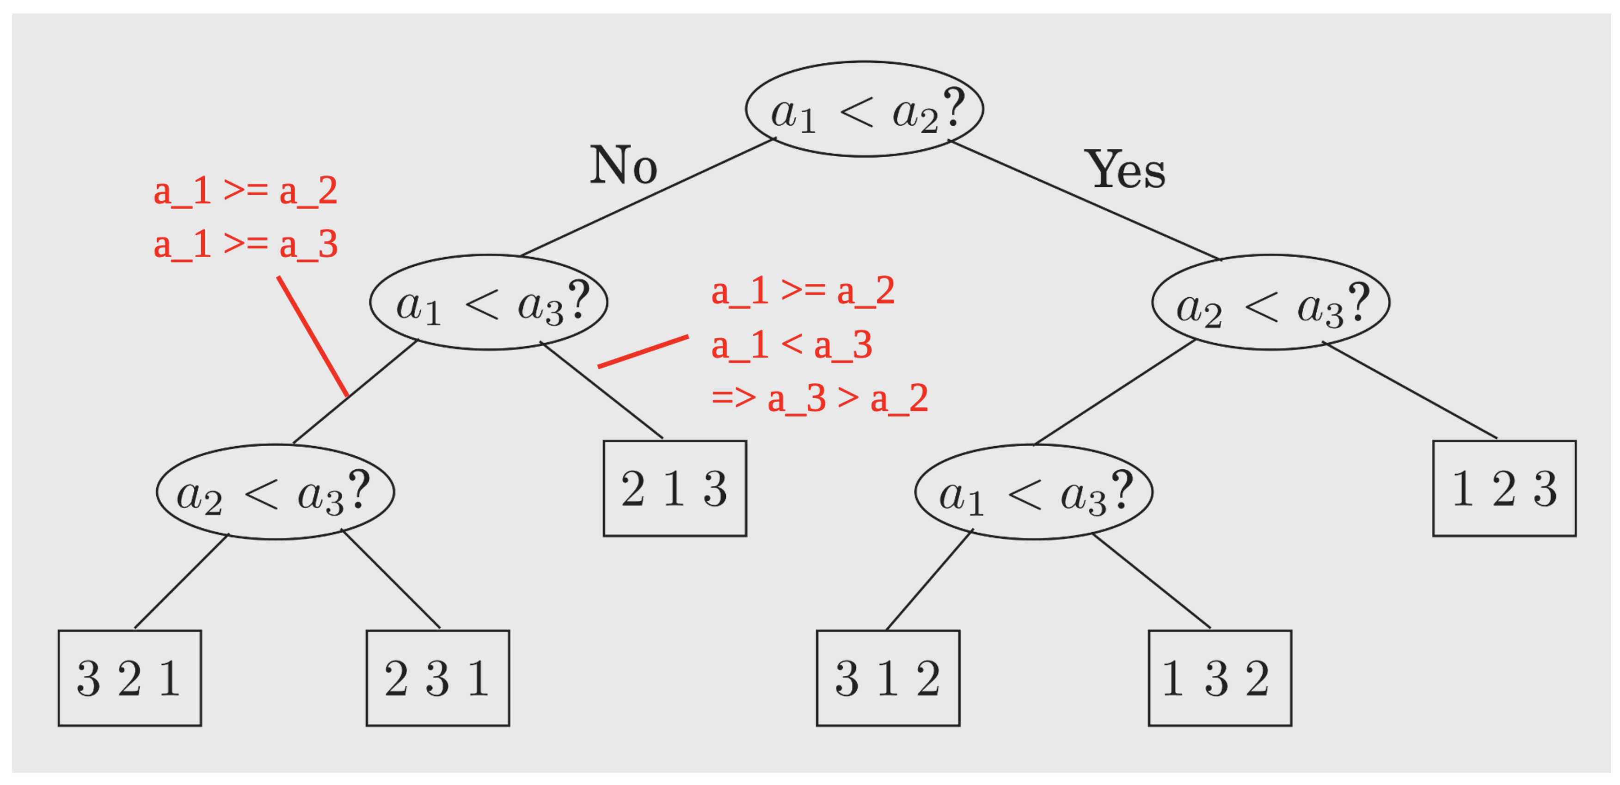

* What is the most compact way possible to consider every possible permutation? Where “way possible” refers to pairwise comparisons.
* Answer: Binary tree as shown above, with every permutation showing up as a leaf.
* Minimum # comparisons (in worst case) longest path from root to a leaf .
* One of the rare instances in which we have a lower bound for an algorithmic problem.

## Divide and Conquer Applications

### Selection Problem

Given as input: an array of items drawn from a totally ordered set, and an integer , identify the smallest item in .

E.g., if , we seek the smallest. If , we seek the largest. If , we seek the (left) median.

A divide and conquer strategy:

* Pick some member of as the *pivot*, .
  + E.g., randomly from amongst all items in .
* *Partition* or *split* around that pivot .
  + Rearrange items in as follows:
    - Move every item to the left of .
    - Move every item to the right of .
    - Thus, every item whose value is ends up where it would in a sorted permutation of .
* Check and recurse.

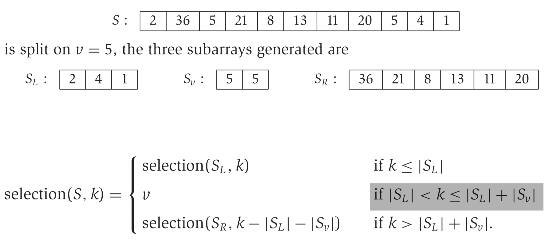

If chosen to be, e.g., median, then .

Challenge is now: How to guarantee a good choice for ?

Suppose “good” is some value in the middle of .

* E.g., if , .

Then, recurrence for running time of :

To pick such a “good” :

* Pick random .
* Check if it is good: .
* If not good, repeat.

So # trials in expectation to get a “good” ,

So, we have an algorithm for , which runs in time in the expected case.

### Matrix Multiplication

Given two matrices, , compute the product .

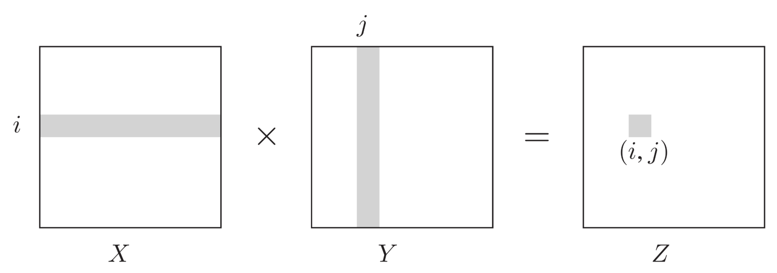

Naïve algorithm to compute scalar multiplications and additions.

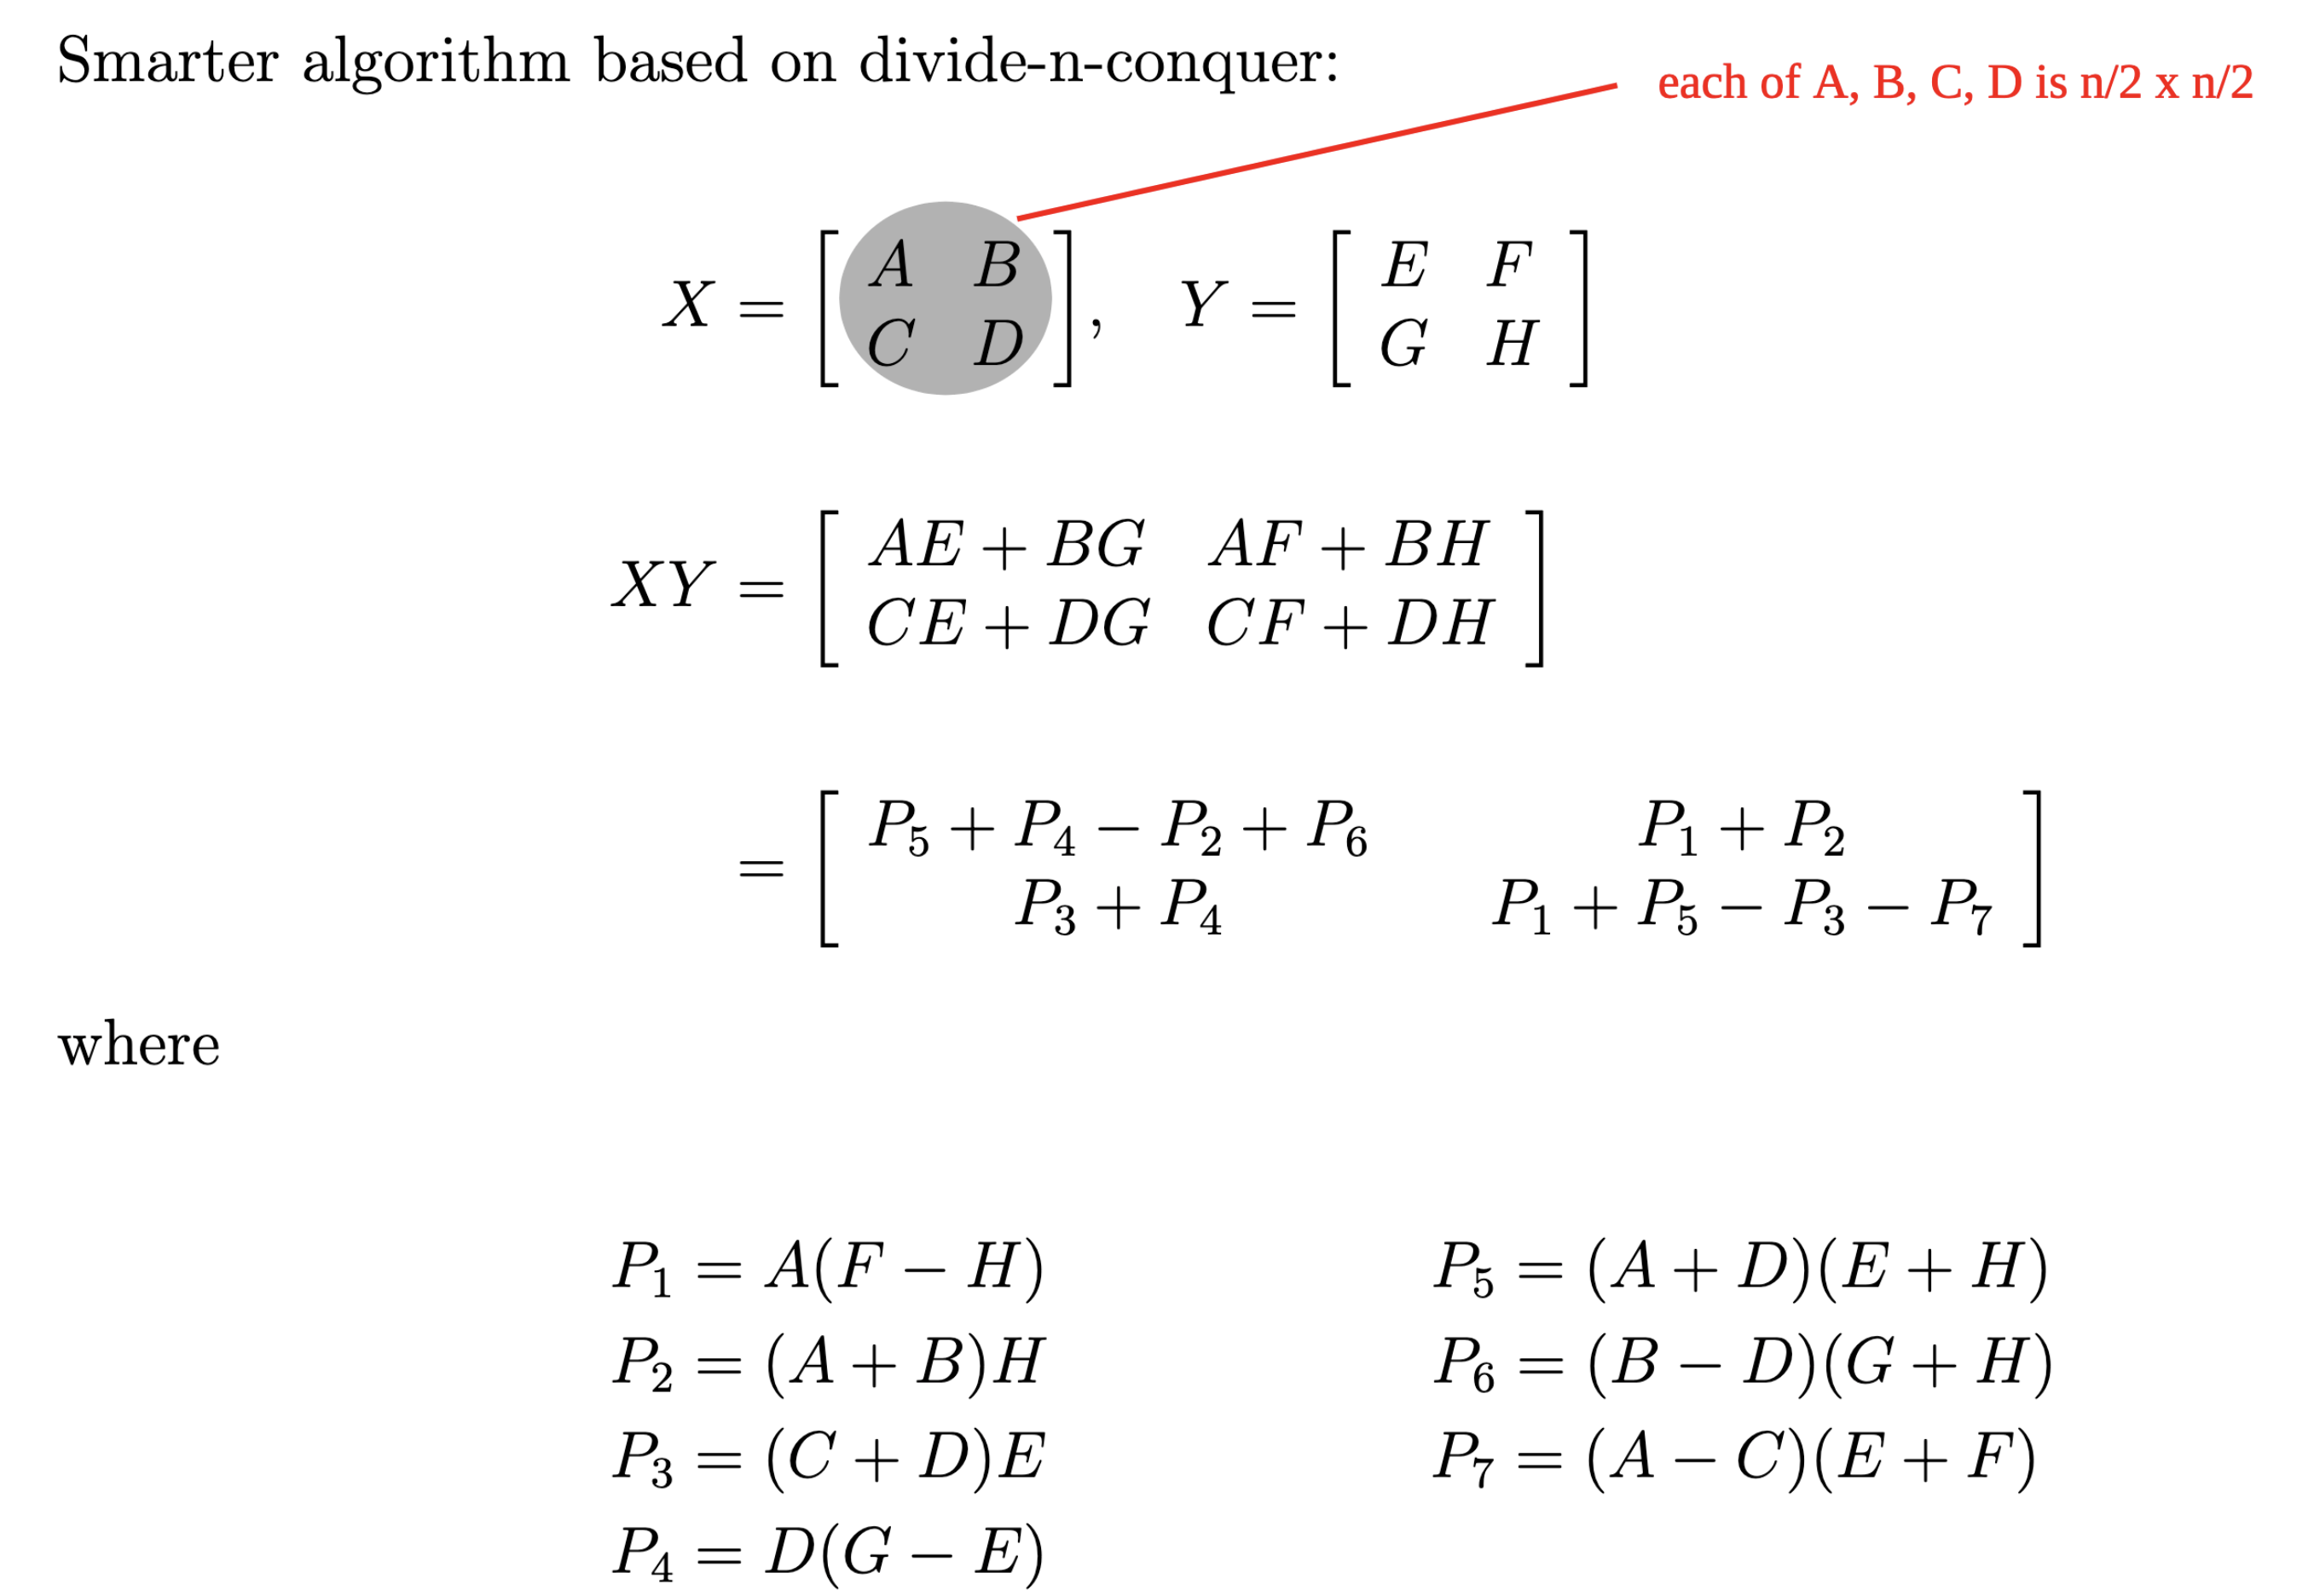

Now, recurrence for # scalar multiplications and additions: